21st Century Lesson: The Outsiders Language Influence
Grade: 9 English Language Arts Subject: English Language Arts

Unit: Novel Studies The Outsiders

Driving Question:
How does language influence and impact beliefs, experiences, values or creativity? Make inferences on what you already know about today’s use of slang versus the 1960’s.

Curriculum Outcomes:
- Give personal opinions through connections and reactions
- Aware that language is used in appropriate settings
- Interpret, select and combine information using strategies and technology
- Evaluate the effectiveness of literary techniques
- Identify and explain connections between new ideas and information and their previous beliefs, values, and experiences
Expected Time:

This is one part of a series of lessons, introducing the students to language use and its effects in creating drama in a novel. This particular lesson should take 40 minutes, or may need to be wrapped up in the following class. It is open for discussion as to time needed to complete the activity.

Resources: [like flipped videos, iPads, etc.]

BYOD, YouTube, Explain Everything (assessable through Edmodo or YouTube), Edmodo, simpleminds+, and rubrics

http://youtu.be/QLXsBUQ6Qbc (Explain Everything flipped lesson)
http://youtu.be/WPGvKwggtl0 (Tim McGraw: “Back Then” music video with lyrics)
http://quizlet.com/2996419/scatter (The Outsiders quizlet)

Rubrics:
Collaboration Rubric
Critical Thinking Rubric
Presentation Rubric

Lesson Procedure |  | 21st century skills
 | Teacher does (I Do):  - Explain that language has specific use and terminology represents the periods of time in which a novel is written.  - Explain that they will use Padlet where they will share, communicate and collaborate their findings and demonstrate their understanding of terms used in the novel.  - They will analyze the differences and changes to the terms used today.  - They will create and publish using Padlet and simpleminds+  - The students will view a song with the lyrics that demonstrates the different meanings of words.  - The students will listen to an Explain Everything lesson video to complete the tasks required of them. | ☒ find, validate  ☒ remember, understand  ☒ collaborate, communicate  ☐ analyze, synthesize  ☐ critical thinking  ☐ evaluate, leverage  ☐ create, publish  ☐ citizenship
 | Individual student work (You Do):  - Listen to the song “Back When” by Tim McGraw  http://youtu.be/WPGvKwggtl0  (Note the expressions and their double meanings either in Pages on iPad, or open the PDF on Edmodo and highlight). Test your knowledge…try this quizlet on 1960’s terms:  http://quizlet.com/2996419/scatter | ☒ find, validate  ☒ remember, understand  ☐ collaborate, communicate  ☒ analyze, synthesize  ☒ critical thinking  ☐ evaluate, leverage  ☐ create, publish  ☐ citizenship
 | Group work (We Do):  - With a partner, share your understanding of the Tim McGraw video, as well as the results of your quizlet.  - With a partner view the list of terms used in The Outsiders novel.  - The list of slang words is accessible on Edmodo or in the Explain Everything lesson. If you need to follow the UDL module, then print off a hard copy from Edmodo.  - Post your opinions of the words on Padlet. Remember to make reference to the Explain Everything video for the criteria needed to post to Padlet.  http://youtu.be/QLXsBUQ6Qbc (Explain Everything)  - Analyze and synthesize how these terms differ in today’s society and what terms today represent the terms of the 1960’s. You share your understanding of these terms using Pic Collage. | ☒ find, validate  ☐ remember, understand  ☒ collaborate, communicate  ☒ analyze, synthesize  ☒ critical thinking  ☒ evaluate, leverage  ☐ create, publish  ☒ Citizenship
 | Class share (We Share):  - Create a Pic Collage or create your own Padlet storyboard or use Simpleminds+ to show the how today’s slang terminology differs from the 1060’s.  - Airdrop your publication or upload to Edmodo.  - We will also airplay your final project! | ☐ find, validate  ☐ remember, understand  ☒ collaborate, communicate  ☐ analyze, synthesize  ☒ critical thinking  ☐ evaluate, leverage  ☒ create, publish  ☒ citizenship
Lesson Wrap Up:
Students are to share with the class the Padlet posts: this can be seen immediately on the smart board as soon as they post. We talk about the differences of then and now. We talk about how society changes throughout the years. We reflect on what has been completed and touch base as to their feelings about needing another class to wrap up.

Differentiation/Modification/Enrichment:

- Edmodo allows for UDL differentiation approach where the students can access a hard copy of the vocabulary.

- Quizlet also allows for text-to-speech to complete The Outsiders terminology:
http://quizlet.com/2996419/learn

- You Tube video on how to use Padlet (Link also on Edmodo):
http://youtu.be/5PoOO-VYNgc

- Explain Everything lesson: on You Tube and Edmodo

Assessment: Rubrics and checklists
Collaboration Rubric
Critical Thinking Rubric
Presentation Rubric
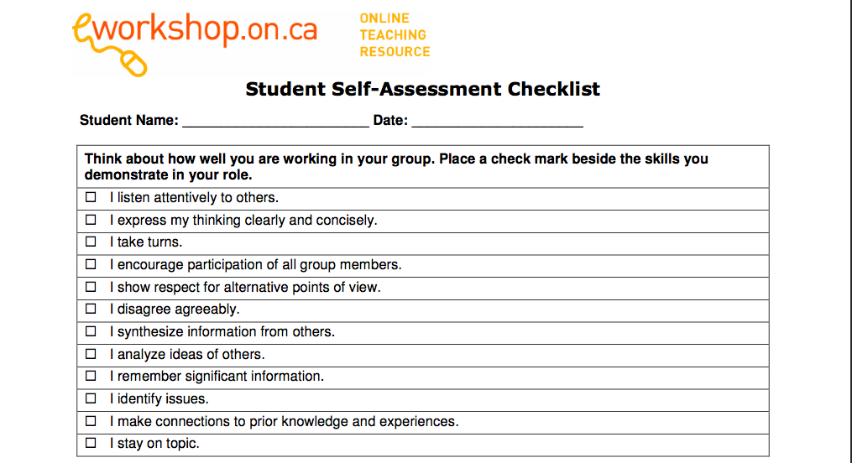
Teacher Reflection:
The students love this novel. We thoroughly enjoy the discussions about gangs and society classes. They love viewing the 1960’s You Tube clip on important events related to this era (Rebellion, Easy Riders, Beatles, war, fashion). Most of them recognized the Tim McGraw song and were able to laugh about the double meaning of the terminology. The students loved using Padlet and seeing the ideas posted immediately from other groups, which created great class discussions, where everyone wanted to share and participate. The online Quizlet was exciting, as they wanted to complete all the links related to the novel. I let them explore, therefore, the final create and publish needed to be done the next day.

