21st Century Lesson : La Carte Postale
Grade: 9 Subject: French Language Arts

Unit: Novel Studies: Je t’Attends à Peggy’s Cove

Driving Question: Students will create an electronic postcard that will represent the summary of chapter 4 of their novel Je t’Attends à Peggy’s Cove. They need to be able to also show the characteristics as to what makes the perfect postcard of Peggy’s Cove.

Curriculum Outcomes:
- Students will be expected to speak and listen to explore, extend, clarify, and reflect on their thoughts, ideas, feelings, and experiences.

- Students will be expected to interpret, select, and combine information using a variety of strategies, resources, and technologies.

- Students will be expected to respond critically to a range of texts, applying their understanding of language, form, and genre.

- Students will be expected to use writing and other ways of representing to explore, clarify, and reflect on their thoughts, their imaginations.

- Students will be expected to create texts collaboratively using a variety of forms for a range of audiences and purposes.

- Students will be expected to use a range of strategies to develop effective writing and other ways of representing, and to enhance their clarity, precision, and effectiveness.
Expected Time:
Typically this lesson takes about 4-5 40-minute classes to complete.

Resources:
BYOD

Explain Everything tutorial on how to do a postcard https://youtu.be/uV5fJOEFTAM

Postcard Creator

handouts( at the end of this lesson)
Lesson Procedure |  | 21st century skills
 | Teacher does (I Do):  With Postcard Creator you can design digital postcards that explains your message in an appealing, professional and effective way. The student will create their postcard to represent a chapter 4 summary. They can use their own images, logos and customised texts. For addressed mailings, simply upload your address file and send it to someone in the class.  The students can follow the steps provided in the link:  postcard creator  The Postcard Creator helps students learn to identify all the typical parts of a postcard, and then generate their own postcard messages by typing information into templates. Students fill in the address, details on the postcard's artwork, and the postcard message. The finished postcard can then be previewed, edited, and printed. After printing their texts, students can illustrate the front of their postcards including drawing a picture, creating a collage of images, or printing and pasting clipart in place. | ☒ find, validate  ☒ remember, understand  ☒ collaborate, communicate  ☐ analyze, synthesize  ☐ critical thinking  ☐ evaluate, leverage  ☐ create, publish  ☐ citizenship
 | Individual student work (You Do):  https://lecoinducervanties.wordpress.com/2011/03/09/ecrire-une-carte-postale/  Using the link above the students will revisit the parts of a post card and then fill out the storyboard handout with the information on chapter 4. | ☒ find, validate  ☒ remember, understand  ☐ collaborate, communicate  ☐ analyze, synthesize  ☒ critical thinking  ☐ evaluate, leverage  ☐ create, publish  ☐ citizenship
 | Group work (We Do):  With a partner, they will collaborate to see if they have all the criteria completed. They will need to be sure that the handout is completed. They can reference the tutorial on how to create a postcard as well as the handout on the parts of a postcard that is on edmodo and in their scribbler.  Then, using postcard creator, they will create a postcard of Peggy’s Cove which they will electronically send to another classmate. | ☒ find, validate  ☐ remember, understand  ☒ collaborate, communicate  ☐ analyze, synthesize  ☒ critical thinking  ☐ evaluate, leverage  ☒ create, publish  ☒ citizenship
 | Class share (We Share):  Once they have completed their postcard and sent it to a classmate, they will then post a copy to Wiggio where the students need to comment on five of the postcards from other students. | ☐ find, validate  ☐ remember, understand  ☐ collaborate, communicate  ☐ analyze, synthesize  ☐ critical thinking  ☐ evaluate, leverage  ☒ create, publish  ☒ citizenship
Lesson Wrap Up:
Before we wrap up, the students will have a 10-minute reminder to collect their material. We will then log onto Wiggio and post what we have done and where we are going and how we felt about the activity. We will talk about the concerns, the likes, and barriers they we may have faced so far. We will then share and reflect how the process went.

Differentiation/Modification/Enrichment:

This activity does not need to be completed digitally, but can be completed using paper and drawings. There are instructions on how to do it by hand with an explain everything screencast.
https://youtu.be/uV5fJOEFTAM

The students can also use pic Collage or even Publisher to create a postcard.

Assessment:
Self assessment rubric (Annexe 1)
Collaboration rubric (Annexe 2)
Presentation rubric (Annexe 3)

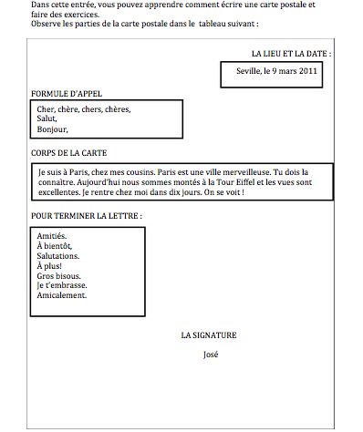

Les Parties de la Carte Postale | Exemple | Votre Plan
L’Adresse Courriel:  Nom de personne  Adresse de la personne dont la lettre est pour. | 45 Ritcey Court  Bridgewater  N.E.  B4V 4A9
Titre de la Carte Postale et image | Peggy’s Cove
Description de l’image | Peggy’s Cove est situé sur le “Lighthouse Route” et environ 25 minutes sud-ouest de Halifax.
Formule d’Appel  A qui la carte est adresse  * n’oubliez pas le virgule. | Cher Papa,
Le Corps de la carte
Ceci est ou vous avez besoin de écrire le résumé du chapitre 4. (4 choses qui représentent la photo parfait de Peggy’s Cove)

Terminer la lettre:  Les derniers mots qui finissent la lettre | Amitiés.  À bientôt,  Salutations.  Je t ‘embrasse.  A plus tard
Votre Nom | Ryan
Timbre | Choisissez un timbre qui représente le Canada ou même la Nouvelle Ecosse.

